INTRODUCTION

After the AIRC have developed the SIC (Inventory and Patrimonial Register System), there was the need to develop a movable inventory and patrimonial register system (called mSIC), so that it would facilitate the verification and inventorying of estates that are considered movables, on their physical place and where they are found. The synchronization of the data between the SIC and the mSIC is made from the text files through the Microsoft Active Sync.

PREPARE THE PDA BEFORE THE INSTALLATION

The existence of the following components in the PDA is necessary, before the installation of the mSIC:

- NETCFv2.ppc.armv4.CAB - Microsoft Compact Framework.
- sqlce20.ppc.wce4.armv4.CAB - SQLCE database engine.
- sqlce20.dev.ppc.wce4.armv4.CAB - Complement for the database engine.
- symbol.all.arm.CAB - Necessary for the reading of the BarCode (it is necessary to install, exactly that the PocketPC does not have reader)

Appealing to the explorer of the Windows, it copies the corresponding files for the PDA (existing in the folder of executable). It executes the files, one of each time.

INSTALL THE MSIC

It is necessary to bind the Dock Station to the PC and to verify that this has the installed ActiveSync.

mSIC is installed by executable an existing one in the PC (mSIC 2.0.msi, existing in the folder of executable). The installation process installs initially an application in the PC, that serves of intermediary for the installation of mSIC in the PocketPC.

STEPS OF THE INSTALLATION

1. It executes the file of installation. It appears the following window.

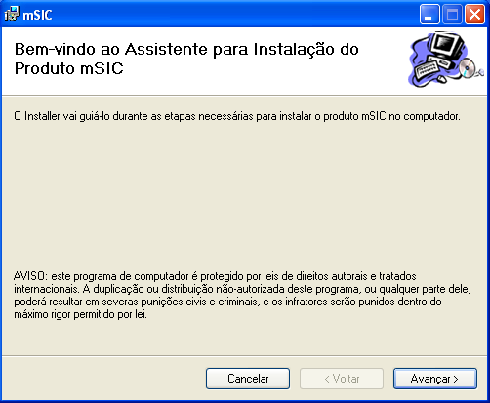

2. Click on button “Avançar” (or “Next”). It appears the following window.

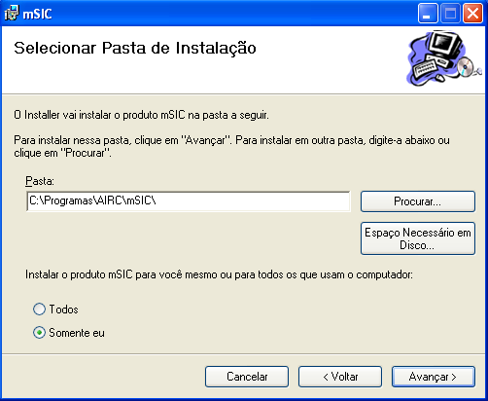

3. Click on button “Avançar” (or “Next”)

After to install the application in the PC, is necessary to proceed to the installation from mSIC in the Pocket.

4. After to appear the following window, click on the button “Sim” (or “Yes”) to install mSIC.
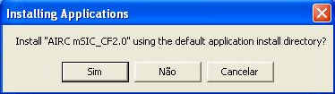

5. After to finish the installation it mSIC, appears the following message.
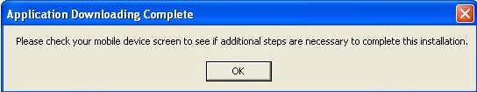

msic is ready to use ☺.

TO INITIATE MSIC

It initiates mSIC through the existing shortcut or through the folder of installation in \Program Files\mSIC\.

Very Important:

The first execution of the application is important, because mSIC creates folders in the memory ROM (essentials in the mechanism of synchronization with the ERP) and also creates the database.

How the certification process is made of an isolated form is necessary to simulate the existing application in PC that communicates with mSIC. It is necessary to copy, through the explorer of the windows, the text files that are in the folder “C:\XPTO” for \AIRC\mSIC\ In\ of the PocketPC.

POPULATE THE DATABASE OF THE MSIC

To synchronize the database of the PocketPC with the ERP it is necessary to effect the following steps:

To initiate

It verifies that the authentication window opened correctly

To write in the TextBox associated to the field “Nome Utilizador”: msicreceber

To write in the TextBox associated to the field “Palavra-passe”: msic

Click in button OK

It verifies that it appears the following message.

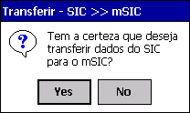

Click in the button “Yes”, to initiate the synchronization process.

It verifies that it appears a new window with a progressbar.

It waits some seconds …

AUTHENTICATION

For security reason it is necessary to proceed to the authentication.

Steps to follow:

To initiate mSIC

It verifies that the authentication window opened correctly

To write in the TextBox associated to the field “Nome Utilizador” (User Name): user

To write in the TextBox associated to the field “Palavra-passe” (Password): pass

Click in button OK

It verifies that the window of the work environment opened correctly.

ENVIRONMENT OF WORK

After the authentication, the user has access to the environment of work of the application.

Here it is the starting point to make all the existing operations in mSIC, such as (the different operations are identified the red in the respective images):

Inventory of Estates: movables, books and vehicles (respectively)

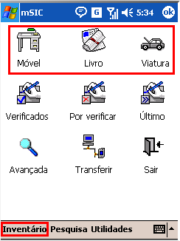

Advanced Research of Estates

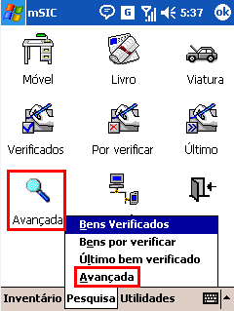

To Consult Estates Verified

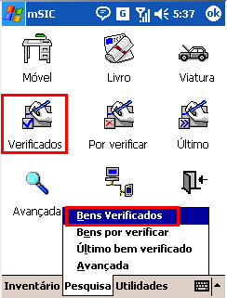

To Consult Estates not Verified

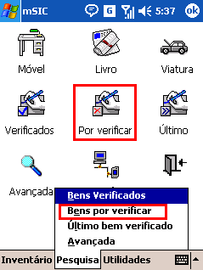

To Consult Last Estates
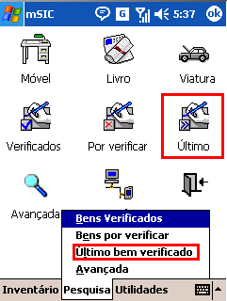

To Transfer Data

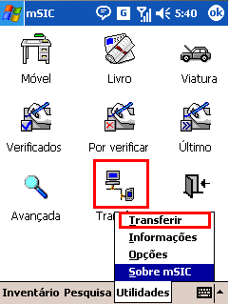

Information

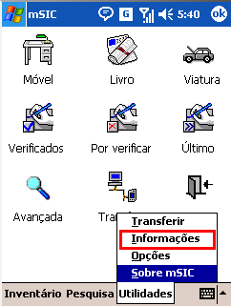

Options of Parameters

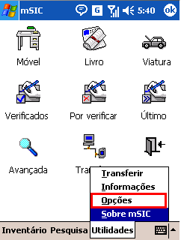

About mSIC
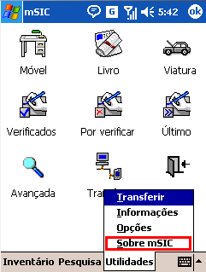

To leave mSIC

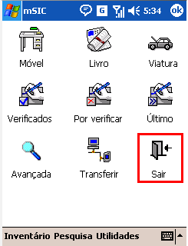

Some of the options of the menu are represented by icons in the environment of work to increase the interaction with the user.
The main identified operations are described in the present document.

INVENTORY OF ESTATES: MOVABLES, BOOKS AND VEHICLES

This operation accedes directly to the inventory window, where it is possible consult, modify and insert estates of the some types (consult topic “Environment of Work”).

The functionalities of this window could be acceded by other operations as it has chance to verify in the present document.

Insert Estate

Introduces in the field “Cód. Barras” (BarCode) a value that does not exist in the existing estates (ex: 1234)

Click in the Button

After the click, if not to fill automatically the all fields of the window, it means that the searched estate was not found.

Click in the Button “OK”

verifies that it appears the following message:
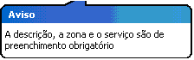
Indicates that it is necessary to fill the fields “Descrição” (Description), “Zona” (Zone) and “Serviço” (Service).

introduces in the field “Descrição” a description of the estate (ex: description1)

introduces in the field “Zona”, through the button […] or of combobox

introduces in the field “Serviço”, through the button […] or of combobox

It can eventually select the separator “Detalhes” (Details) and fill some of the existing fields.

Click in the Button “OK”

verifies that the filled fields had been clean (it means that it inserted the estate correctly).

Consult Estate

Introduces in the field “Cód. Barras” (BarCode) a value that exist in the existing estates (ex: 1234)

Click in the Button
If to appear the following message
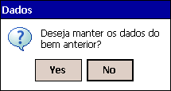

Click in the Button “Yes”, to keep the data of the previous estate.

It makes alterations to the fields that think indicated.

Click in the Button OK

Verifies that the filled fields had been clean (it means that it inserted the estate correctly).

Click in the Button X

Verifies that it came back to the window of the work environment.

ADVANCED RESEARCH OF ESTATES

To accede to this window it consults topic “Environment of Work”.

Here it is possible to make research of the different types of estates, with the support of some existing criteria of research. The window is divided in two separators, the “Principal” (Main) and of “Detalhes” (Details).

Translated window:

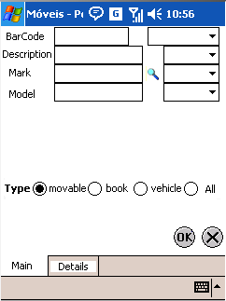

Points to have in attention

If not to fill none of the existing criteria the existing estates are searched all.

If to want to fill the existing fields must define research criteria.

important translations

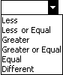

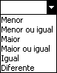

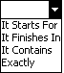

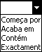

The button it serves to fill the fields associates (opens a new window to select the item).

After to fill the research criteria is necessary to make click on button OK.

If appear the following message, it means that the estate was not found.


If not, verifies that it appears a new window with the result of the research.

After the window opening, makes double click on one of items listed.

Verifies that it opens the window of inventory of the corresponding item.

Click in the Button OK.

Verifies that it came back to the previous window (listing of the research).

Click in the Button OK.

Verifies that it came back to the window of the work environment.

CONSULTAR BENS VERIFICADOS

Accede to the window of estates verified from the work environment (consultar tópico “Ambiente de Trabalho”).

Here the estates are listed that had been consulted from the inventory window and verified from existing button OK in the window .

Can make double click on the goods for consults them in the inventory window.

CONSULTAR BENS NÃO VERIFICADOS

Accede to the window of estates not verified from the work environment
(consultar tópico “Ambiente de Trabalho”).
Here the estates are listed that had not been verified from button OK, existing in the inventory window

When making double click on a estate will be able consults it in the inventory window and to clicar on button OK, moving it for the category of verified estates.

CONSULTAR ÚLTIMO BEM

Can consult the details of the last (that it was verified).

TRANSFERIR DADOS

After to have effected all the operations on the estates is necessary to synchronize the data with the ERP.
As the certification process is made separately we will make only the operation of exportation of data, that it consists of cleaning the database and creating text files with the information of the operations effected on the estates (folder \AIRC\mSIC\Out\).

Steps to follow :

Accedes to the window of transference of data (consultar tópico “Ambiente de Trabalho”).

Click on the image that will count the text “Envio” (Sending) (underlined the red )

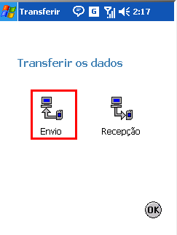

verifies that it appears the following message (to ask if it intends to synchronize the data with the ERP).

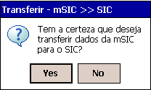

Click in the Button YES

Verifies that it appears a new window with a progressbar.

Verifies that in the end of the operation mSIC closes automatically.

